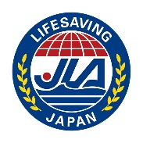
The 38th Japan National Lifesavi ng Pool Championships
Consent Form

- The registered competitors of the team fulfill the eligibility requirements of the competition organizers.
- The registered competitors of the team will follow the regulations and directions of the Competition Organizer and will cooperate for smooth operation and procedure for the competition.
- The registered competitors of the team will be responsible for my personal belongings and will not question the responsibility of the competition organizer during the competition.
- If sustained damage due to negligence from competition organizers or other affiliates appointed by the Organizer, I will not claim for liability regardless of negligence.
- The registered competitors of the team are in good physical health and am well-prepared for this competition.
- If in any case of any accident during the competition, the registered competitors of the team agree to have emergency treatment by the competition organizer.
- The registered competitors of the team agree and admit to entrust the right of publicity to the competition organizer.
- We acknowledge that the registered family members, relatives and guardians of the athlete understand the content of the competition and have agreed to participate in the competition.
I have well read the above 1.~8.
I myself as the Team Manger and all the competitors within the team understand and agree.
Team Name
Team Manager Name
Team Manager Sign

Date | Day / Month / Year

